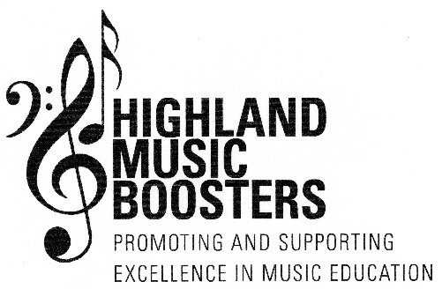
2019-2020 RECOGNITION AWARD INFORMATION

WHO QUALIFIES: Any student who is currently enrolled in our district’s choral and/or band programs (grades 4-12)
Any student who currently takes private instrumental/vocal lessons, from a certified instructor, on a
regular basis (written proof from private instructor will be required)

WHAT ARE RECOGNITION AWARDS? The Highland Music Boosters’ Recognition Awards provides our organization with an additional opportunity to
recognize our students’ musical accomplishments as well as provide them with monetary assistance ($100.00)
to continue their musical development throughout the year.

WHERE DO I GET AN APPLICATION? Applications are available. They can be:
- Downloaded from our district webpage (http://www.highland-k12.org/webpages/hboosters)
- Downloaded from our Facebook page (https://www.facebook.com/HighlandMusicBoosters)

WHEN ARE THEY DUE? Completed applications must be returned on or before Friday, January 17, 2020. They may be electronically
sent to us at musiccounts@hotmail.com or returned to the main office of your child’s school. Please place the
application in the box labelled Highland Music Boosters.

WHY SHOULD STUDENTS APPLY? This is a great opportunity to be recognized for your musical accomplishments and receive $100.00 towards
any music activity of your choice! (Examples include, but are not limited to: lessons, music camp, instrument
maintenance or repair, purchase of music literature, additional preparation for NYSSMA, etc.)

HOW ARE RECIPIENTS CHOSEN? Completed applications are submitted anonymously to a selection committee for consideration. Recipients will
be notified prior to the presentation of the awards. Awards will be presented at a scheduled event before the
end of the school year.

DON’T MISS OUT – GET STARTED ON YOUR APPLICATION TODAY!
ANY FURTHER QUESTIONS? CONTACT US AT:musiccounts@hotmail.com

