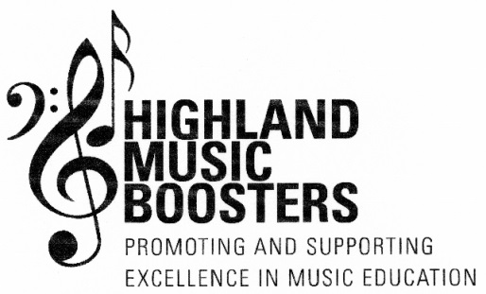
2019-2020 RECOGNITION AWARD APPLICATION
Student’s Current Grade Level: ______________________
Student applicant is currently enrolled in: Band Chorus Private Instruction (Circle those that apply)
If enrolled in band or private instruction, what instrument does applicant play:___________________
**All private instruction students MUST attach a signed letter from their instructor (on letterhead stationary) verifying established lesson schedule for the year & performance level (beg./inter./advanced)**
List all instruments that applicant is currently receiving instruction on:______________________________
_______________________________________________________________________________________
List all musical organizations that applicant is currently a member:_________________________________

List all festivals applicant has auditioned for, including name of festival, year of audition and whether or not they were accepted. (Examples include: All-County, Area All-State, All-State, NYSSMA):_________________
_______________________________________________________________________________________
Directions: Items A-C are to be completed by the student applicant. (Be specific and include examples)
- List, and briefly explain, three ways that your musical experience this year in school has benefitted you.
1._____________________________________________________________

_____________________________________________________________

2. ______________________________________________________________

______________________________________________________________

3.______________________________________________________________

______________________________________________________________
B. List, and briefly explain, three reasons why you feel that you should receive a HMB
Recognition Award.

- _____________________________________________________________

- _____________________________________________________________

- _____________________________________________________________

- How would you use your summer experience to motivate others in your performance
group?_________________________________________________________________________

__________________________________________________________________________________

(1 of 2)

2019-2020 RECOGNITION AWARD APPLICATION – PAGE 2

Student Name: __________________________________________________
Parent/Guardian: __________________________________________________
Mailing Address: __________________________________________________
__________________________________________________
Home Telephone #:__________________________________________________
Cell Phone #: __________________________________________________
E-Mail Address: __________________________________________________

2019-2020 Release for use of Photographs

The Highland Music Boosters, Inc. plans to use photographs of some children currently enrolled in the Highland Central School District, but will not use a photograph of any child unless we have first received written consent from a custodial parent or guardian both releasing our organization and the district from any claim for invasion of privacy, or any other action in connection with our use of the photograph in the publications that you have checked below.

Therefore, the HMB is asking for permission from you to allow us to include a photograph of your child in the publications you have checked below. If you are willing to grant consent to the inclusion of your child’s photograph, please sign the following consent release. The signing of this release does not obligate the HMB to use your child’s photograph.

I, ____________________________, hereby grant permission to the Highland Music Boosters, Inc. to
(name of parent/guardian)
Include photographs of my child/ward in the publication that I have checked below to be published and distributed by the Highland Music Boosters, Inc. By granting permission, I release the organization from any liability for, and waive any and all claims against the HMB Organization by reason of the inclusion of the photograph in the following publications, including but not limited to unlawful invasion of privacy.

I understand that the signing of this release does not obligate the Highland Music Boosters, Inc. to use my child’s/ward’s picture.

I give the Highland Music Boosters, Inc. permission to include my child’s/ward’s photograph in only the following: (Please check all those that apply):

_______ The Highland Music Booster, Inc. Newsletter
_______ The Highland Central School District website (includes the Music Boosters link)
_______The Highland Music Boosters, Inc. Facebook page
_______Photographs that we submit to local newspapers

Child’s Name:___________________________________________________________________

Parent/Guardian Signature:_____________________________________Date:_______________

(2 of 2)

